# 

# Visvesvaraya Technological University

# Belagavi, Karnataka, 590 014.



## **AICTE Activity Point Programme on**

**“Local Tourism Through Innovative Approaches”**

(Non-Credit Activity of 2 Weeks (80-90 hours))

Submitted in partial fulfillment of the requirements for the award of

**Bachelor of Engineering**

**in**

**Computer Science and Engineering**

**Semester IV**

**Academic Year 2021-22**

***Department of Computer Science & Engineering***

|  |  |  |
| --- | --- | --- |
| **klesociety** | K. L. E. SOCIETY’S**K. L. E. INSTITUTE OF TECHNOLOGY,**Opp. Airport, Gokul, Hubballi-580 030Phone: 0836-2232681 Website: www.kleit.ac.in | **kle-logo** |

# Bagalkot

**List of the sites Page No.**

1. Aihole 1-9

2. Pattadkal 10-16

3. Bidar Fort 17-25

4. Badami Caves 26-33

5. Kudalasangama 34-41

6. Almatti Dam 42-53

**Group Members**

1. Sagar Hiremath 2KE20CS076

2. Shreeraksha C. Singatalur 2KE20CS093

3. Shrinivas Galaraddi 2KE20CS096

4. Shrusti A. Kori 2KE20CS097

5. Srushti Raghavendra Shettar 2KE20CS101

6. Sumant Shivakumar Nidoni 2KE20CS102

7. Sunidhi Patange 2KE20CS103

8. Veerendra Patil 2KE20CS106

9. Vinayshree P. Hiremath 2KE20CS107

10. Zeenatkausar A. Topinkatti 2KE20CS111

11. Sahana R. M 2KE20CS115

**\*\*\*\*\*\*\*\*\*\*\*\*\*\*\*\*\*\*\*\*\*\*\*\*\*\*\*\*\*\*\*\*\*\*\*\*\*\*\*\*\*\*\*\*\*\*\*\*\*\*\*\*\*\*\*\*\*\*\*\*\*\*\*\***

**How to Reach Bagalkot:**

**By Road:**

Bagalkot is connected by read to some of the major cities nearby National Highway NH 161 which connects Hubli and Bidar passes through Bagalkot. The other places that falls on the highway include Bijapur, Jewargi, Gulburga and Humnabad. By road Bagalkot is surrounded by Ramdurg, Nargund, Bijapur which are 29.92 km, 36.81 km, 44.99 km away respectively. These places are ideal spots for people to plan their short weekend break.

**By Train:**

Besides flying you can also reach Bagalkot through train. On an average about 24 trains pass through Bagalkot on a daily basis.Gadag-Betigeri to Bagalkot, Badami to Bagalkot, Bangalore to Bagalkot are some of the most popular routes to Bagalkot with 38, 34, 25 trains weekly respectively. Bagalkot Railway Station is connected to places like Bijapur, Solapur, Dharwad, Bellary, Mysore, Hyderabad, Ahmedabad and Mumbai.

**By Air:**

On a daily basis there are approximately 16 flights that operate at Hubli Airport. SpiceJet is the popular airline brand that fly frequently to this airport**.**

The nearest Airport to Bagalkot is the Hubli Airport which is around 110km away. The Sambre Airport at Belgaum is around 130km from Bagalkot.

**\*\*\*\*\*\*\*\*\*\*\*\*\*\*\*\*\*\*\*\*\*\*\*\*\*\*\*\*\*\*\*\*\*\*\*\*\*\*\*\*\*\*\*\*\*\*\*\*\*\*\*\*\*\*\*\***

**CHAPTER 1**

**AIHOLE**

**1.1 AIM**

Survey Of Aihole and its history.

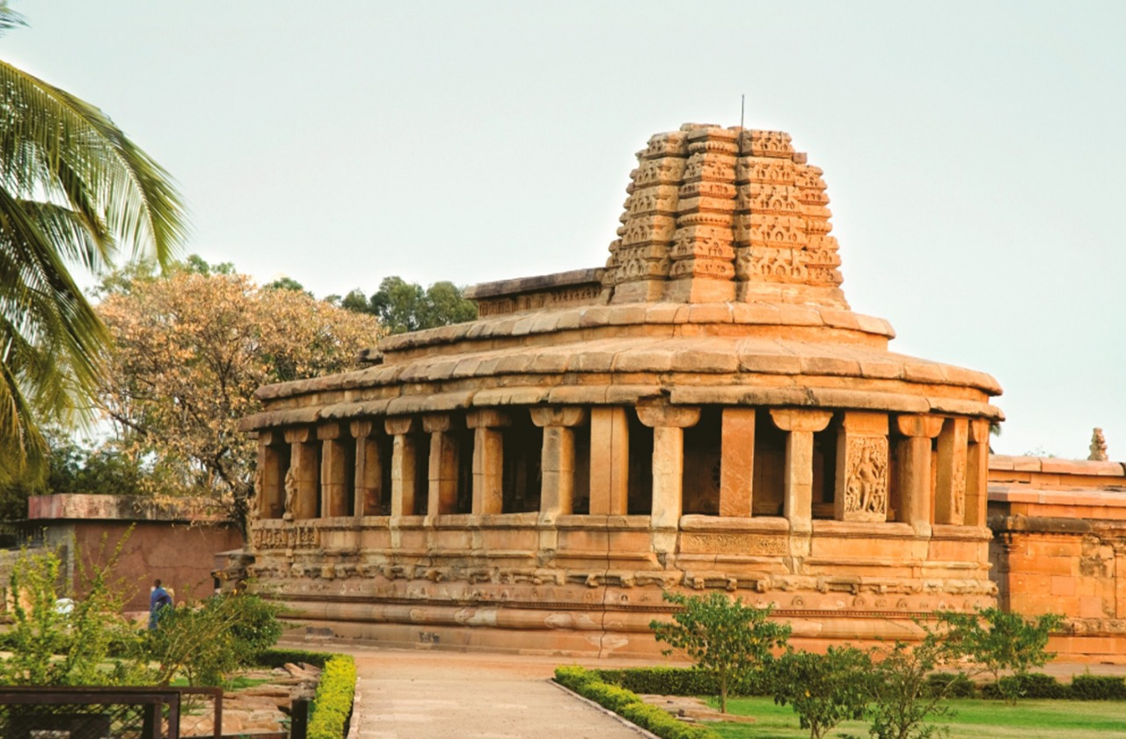

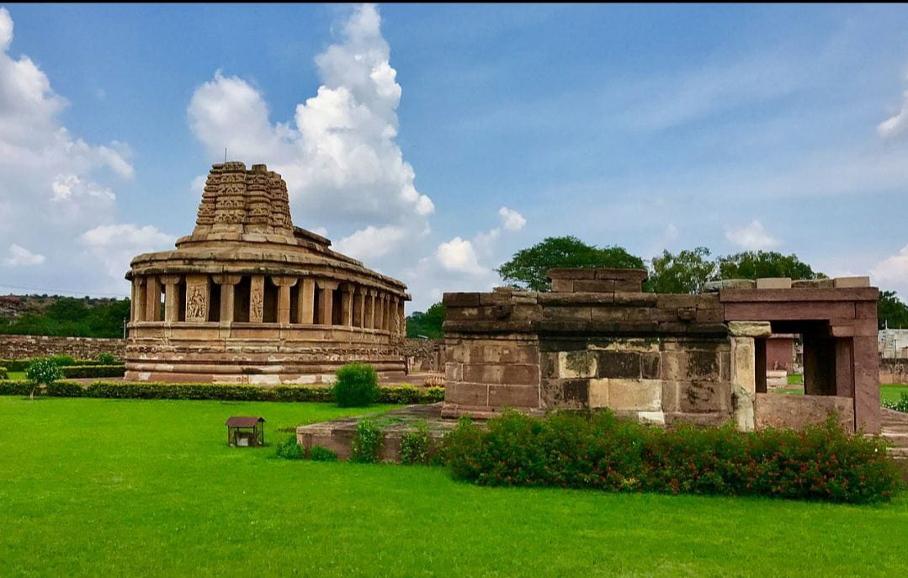

**Fig. 1.1: Durga Temple Cluster At Aihole**

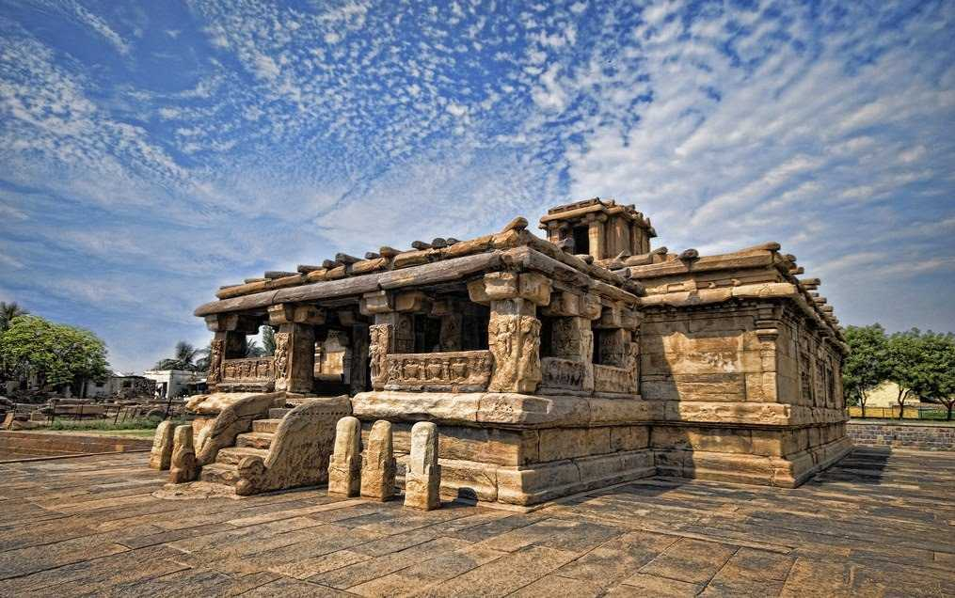

**Fig.1.2: Lad Khan Temple**

***"The Cradle of* Hindu *Rock Architecture"***

Home to over 125 beautiful Chalukyan temples and monuments, Aihole is a historical site in Bagalkot, Karnataka. It was declared a UNESCO World Heritage site and is surrounded by marvellous sandstone hills and villages on the banks of the Malaprabha River. It was formerly the capital of the Chalukya Dynasty with over 100 Hindu and Jain temples dating back to around 6th to 12th century. Excavation and investigation into the history of Aihole continues and several thousand tourists seek out the serene and spiritual ambiance of this city every year.

Aihole, known initially as Ayyavole or Aryapura, played a significant role in Hindu mythology. Among the numerous temples scattered in Aihole, the most noteworthy among them is the *Durga Temple* composed of a semicircular apse, an elevated plinth and a gallery encircling the sanctum. The *Lad Khan Temple* is one of the earliest temples in the region and was initially a royal assembly hall and marriage mantapa. It was the chosen abode of the Muslim chief Lad Khan. Other major attractions in the area are the *Huchimalli Temple* with a sculpture of Lord Vishnu sitting atop a cobra, the *Ravalphadi Cave Temple* which celebrates the various incarnations of Lord Shiva, the *Konti Temple Complex*, *the Umamaheswari Temple*, *the Jain Meguti Temple*, and the *two-storied Buddhist temple*.

**1.2 HISTORY**

There's an interesting story about how the town got the name. Legend has it that Lord Parashurama, after avenging the death of his father, Sage Jamadagni came to the river Malaprabha to wash his battle axe and bloodstained hands. While doing so, the blood turned the colour of the river water to red. Seeing this horrifying sight, a woman screamed ‘Ayyo Hole!’ in Kannada, which translates to 'Oh no! Blood!’. Thus, this town got the name Aihole. However, this place is also called ‘Ayyavole’ and ‘Aryapura’.

Aihole has great significance to the Ramayana in the Rishi Gautama and the Ahilya part in the epic. In the town, there exists an axe-shaped rock with a foot imprint on it. These prints are said to have belonged to Parashurama.

**1.3 HOW TO REACH AIHOLE**

Aihole is 450 km from Bengaluru. Hubballi is the nearest airport (140 km from Aiholë). Badami and Bagalakote are the nearest train stations (both 35 km from Aiholë) Aihole has good bus service and road connectivity from Bengaluru and other parts of Karnataka.

**1.4 LOCATION**

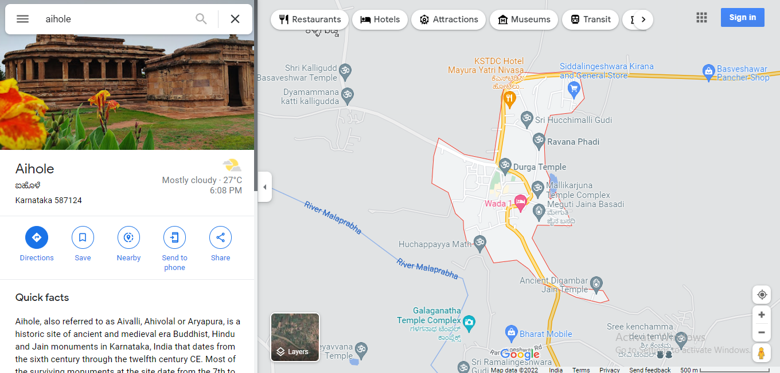

**Fig 1.3: Location Of Aihole**

**CHAPTER 2**

**PATTADAKAL**

**2.1 AIM**

Survey Of Pattadakal and its history

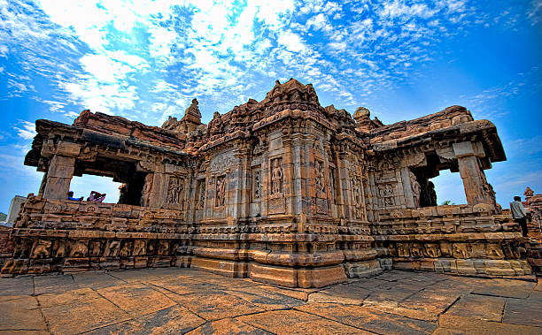

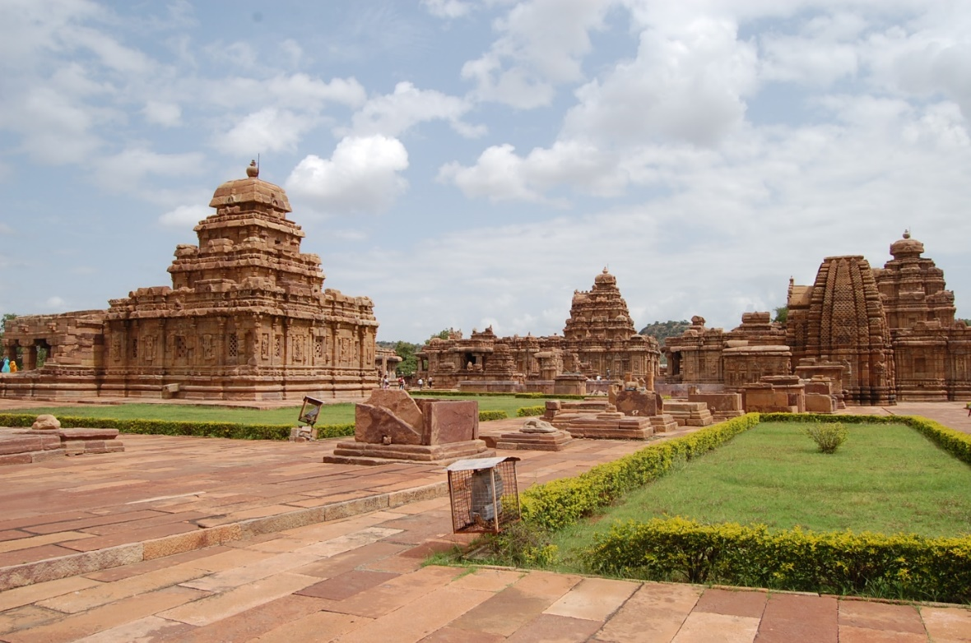

**Fig 2.1: Group Of Temples At Pattadakal**

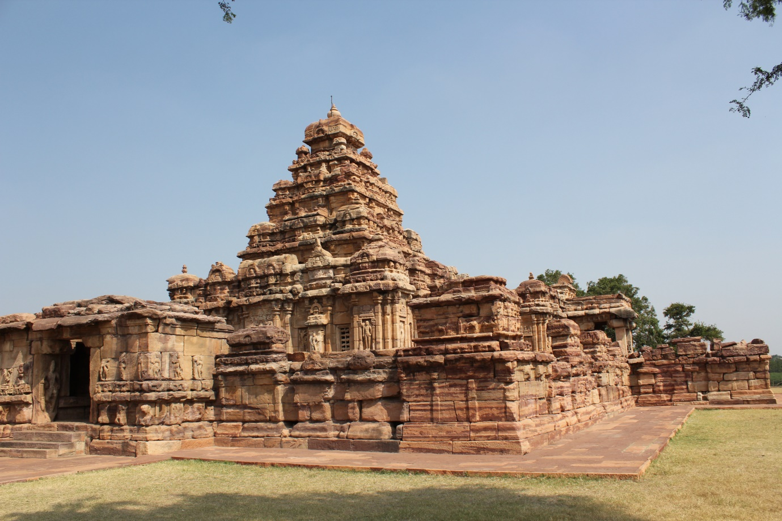

**Fig 2.2: Virupakasha Temple**

**Pattadakal**, also called **Paṭṭadakallu** or **Raktapura**, is a complex of 7th and 8th century CE Hindu and Jain temples in northern Karnataka (India). Located on the west bank of the Mallaprabha River in Bagalkote district, this UNESCO World Heritage Site is 14 miles (23 km) from Badami and about 6 miles (9.7 km) from Aihole, both of which are historically significant centres of Chalukya Monuments The monument is a protected site under Indian law and is managed by the Archeology Survey of India (ASI).

**2.2 LOCATION**

The Pattadakal monuments are located in the Indian State of Karnataka, about 165 kilometres (103 mi) southeast of Belguam, 265 kilometres (165 mi) northeast from Goa, 14 miles (23 km) from Badami, via Karnataka state highway SH14, and about 6 miles (9.7 km) from Aihole, set midst sandstone mountains and Malaprabha river valley. In total, there are over 150 Hindu, Jain, and Buddhist monuments, and archaeological discoveries, dating from the 4th to 10th century CE, in addition to pre-historic dolmens and cave paintings that are preserved at the Pattadakal-Badami-Aihole site.

**2.3 HISTORY**

Pattadakal ("place of coronation") was considered a holy place, being where the Malaprabha river turned northwards towards the Himalayas and the Kailasha mountain (*uttara-vahini*). As its name implies, it was used during the Chalukya Dyanasty for coronation ceremonies, such as that of Vinayaditya in the 7th century CE. Other names this place was known by were Kisuvolal meaning "valley of red soil", Raktapura meaning "city of red", and Pattada-Kisuvolal meaning "red soil valley for coronation". The site, states Archaeological Survey of India, is mentioned in texts by Srivijaya and is referred to by Ptolemy as "Petirgal" in his *Geography*.

The early rulers of the Chalukya during the 5th - 6th century were Vaishnavites (a community that believes and offers prayers to Lord Vishnu, followers of Vaishnavism) and then converted themselves into Shivaites (a community that believes and offer prayers to Lord Shiva and followers of Shivaism). Hence the temples in and around this compound are dedicated to Lord Shiva.

**2.4 OTHER MONUMENTS AND INSCRIPTIONS**

Number of inscriptions in the old Kannada language have been found at Pattadakal, notably in the Virupaksha, Sangameshwara and Papanatha temples. These inscriptions are an important source of information regarding the grants made by King Vikramaditya, and Vijayaditya, various queens, and others, for the construction and operation of the temple. They have also provided valuable insight into the evolution of various written Indian scripts.

**2.5 LOCATION**

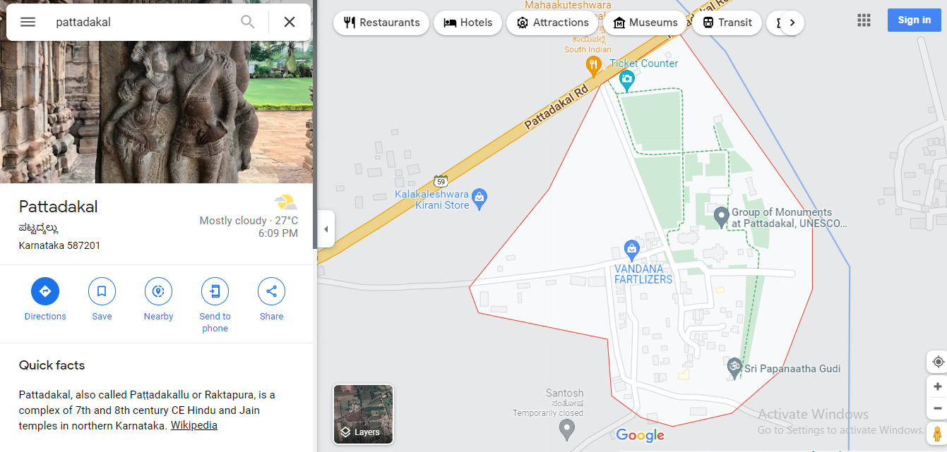

**Fig 2.3: Location Of Pattadakal**

**CHAPTER 3**

**BADAMI CAVES**

**3.1 AIM**

Survey Of Badami Caves and its history

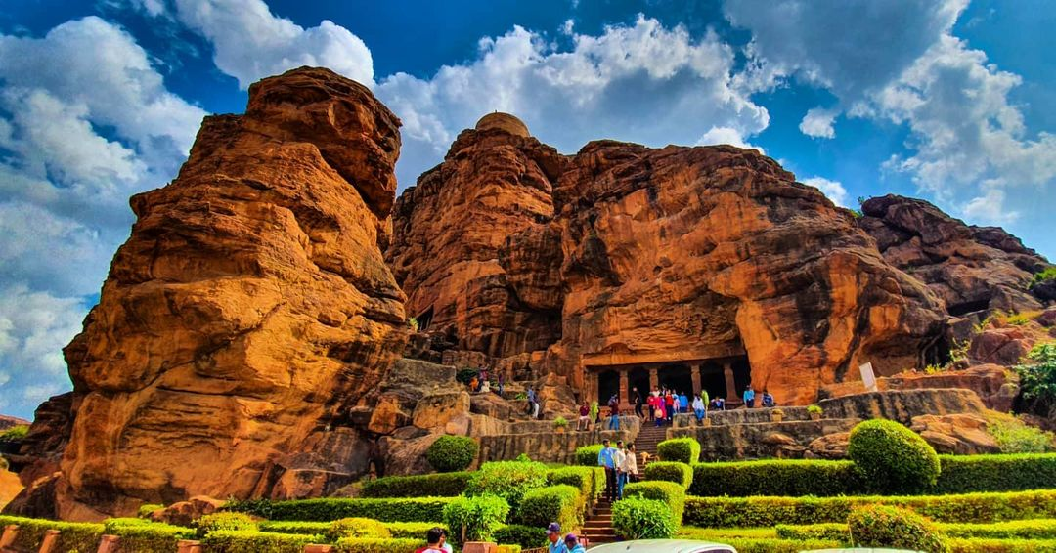

**Fig 3.1: Entrance To Cave 1**

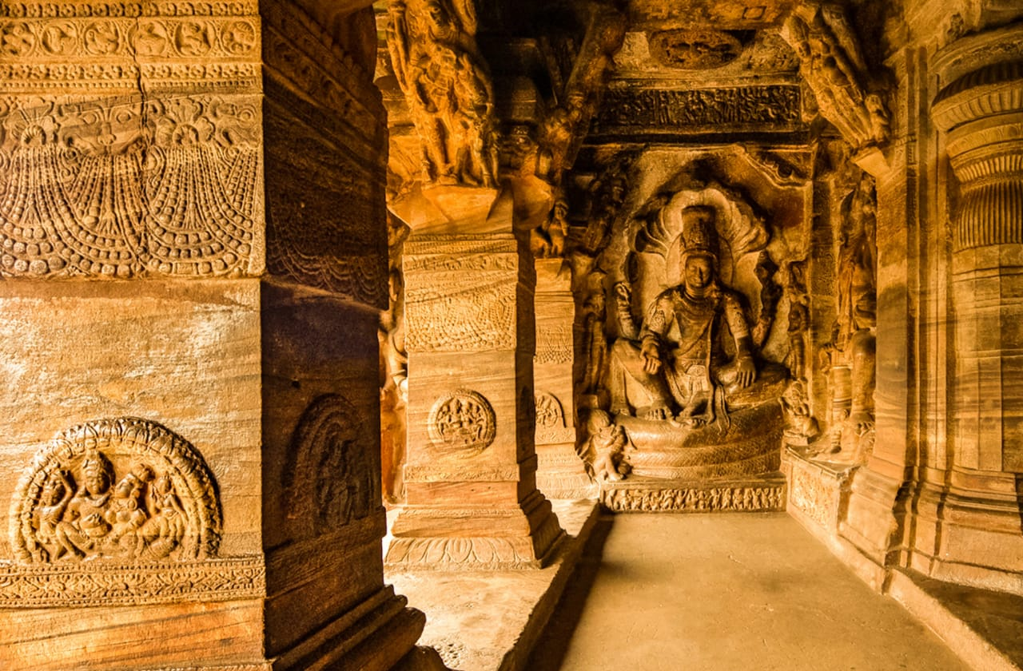

**Fig 3.2: Vishnu Seated on Serpent Sesha in cave 3**

* 1. **HISTORY**

The cave temples, numbered 1 to 4 in the order of their creation, in the town of Badami the capital city of the chalukya kingdom .re dated from the late 6th century onwards. The exact dating is known only for Cave 3, which is a temple dedicated to Vishnu. An inscription are found here records the dedication of the shrine by Mangalesh .The inscription, written in the kannada language has enabled the dating of these rock cave temples to the 6th century.This makes the cave the oldest firmly-dated Hindu cave temple in India.

**3.3 TEMPLE CAVES**

The Badami cave temples are carved out of soft Badami sandstone on a hill cliff. The plan of each of the four caves (1 to 4) includes an entrance with a verandah (*mukha mantapa*) supported by stone columns and brackets, a distinctive feature of these caves, leading to a columned mantap, or main hall (also *maha mantapa*), and then to the small, square shrine cut deep inside the cave.The cave temples are linked by a stepped path with intermediate terraces overlooking the town and lake. The cave temples are labelled 1–4 in their ascending series; this numbering does not reflect the sequence of excavation.

The architecture includes structures built in the NAGARA and Dravidian styles, which is the first and most persistent architectural idiom to be adopted by the early chalukyas.

**Cave 1**

Cave 1 is about 59 feet (18 m) above ground level on the north-west part of the hill. Access is through a series of steps that depict carvings of dwarfish ganas in different postures as if they hold the cave floor. The verandah, with an inner measurement of 70 feet (21m) by 65 feet (20 m), has five columns sculpted with reliefs of flower garlands, foliage and jewellery.

The cave portrays the tanadava dancing Shiva as NATARAJ on the rock face to the right of entrance and also part of Gandharveda. The image, 5 feet (1.5m) tall, has 18 arms (9 in left and 9 on right) in a form that expresses the dance position (about 9x9=81 combinations in total) arranged in a geometric pattern, which alice boner–a Swiss art historian and indologist , states is a time division symbolizing the cosmic wheel.

**Mahisasura mardhini carving**

On the right side of the Nataraja carving is an amazing carving of mahisasura mardhini with Chaturbhuja (Chatur means 4, Bhuja means hands). The sculpture depicts the killing of the Assura (daemon) Mahishaasura by Goddess Durga. Mahishasura was the son of Mahisi and great grandson of Bhahmarishi Kashyapa.

**Harihara Carving**

Once inside the veranda, the cave presents a carved sculpture of harihara, a 7.75-foot (2.36m) high sculpture of a fused image that is half-Shiva and half-vishnu. He is flanked on respective sides with the goddess parvati and laxmi.

**Ardhanareshwara Carving**

To the right, toward the end of the wall, is a relief sculpture of Ardhanareshwara, a fused image of Shiva and his consort Parvati. One half of the image has Shiva with a moon on his mukuta (head), snakes in his hands, earings and next to the half that represents Parvati is an attendant carrying a tray of jewels. Next to the Ardhanarishvara half that represents Shiva is Nandi the bull, and skeletal bhringi a devotee of Shiva.The Bhringi sadhu carvings shows the advance knowledge of anatomy for the whole body which includes the Skulls, Ribs, bones on hands and legs.

**Cave 2**

Cave 2 is above and to the east of Cave1 and faces north. It was created in late 6th or early 7th century. It is smaller than Cave1, somewhat similar in terms of its floor plan, but it is dedicated primarily to Vishnu.Cave 2 is reached by climbing 64 steps from the first cave. The cave entrance is a verandah divided by four square pillars with ends as half pillars, all carved out of the monolithic stone face. The pillars have decorative carvings with frieze of  *ganas*(mythical dwarfs) with various facial expressions. On the two sides of the entrance are standing *dvarapalas*(guardians) holding flowers, not weapons. Like Cave1, Cave 2 art reflects Hindu theology and arts.

**Cave 4**

Located immediately next to and east of Cave 3, Cave 4 floor is situated about 10 feet lower and is the smallest of the four. It is dedicated Trithankaras , the revered figures of . It was constructed after the first three, sponsored by Hindu kings in later part of the 7th-century.Some scholars state this cave may have been created in the 8thcentury. Some embellishments were likely added in later centuries until about the 11th or 12th century.

**Other caves**

Other than the numbered caves, Badami is home to many other cave monuments and medieval era temples.On the other side of the lake, near the Bhutanatha temple, is a 7th-8th century Chalukya period cave of small dimensions. Inside, there is a carved statue seated over a sculpted throne with reliefs showing people holding chauris(fans), a Pipal tree,elephants, and lions in an attacking pose. On one side of the statue is a chakra, on the other a conch shell. The statue wears abundant jewellery and a thread over its chest. The face of this statue is damaged and missing its face.

There are several theories as to who the statue represents. One theory holds that it is a relief of the Buddha in a sitting posture. This is supported by two chauris bearers who may be Bodhisattvas flanking the Buddha. According to George Michell, the halo, the Pipal tree, and cloak-like dress suggests that this was originally a Buddha statue. According to B.V.Shetti–archaeologist and curator of Prince of Wales Museum of Western India, the cave was not converted but from the start represented a tribute to mayamoha of the Hindu Puranas, or buddhavatara *vishnu* (ninth avatar of Vishnu).

**3.4 LOCATION**

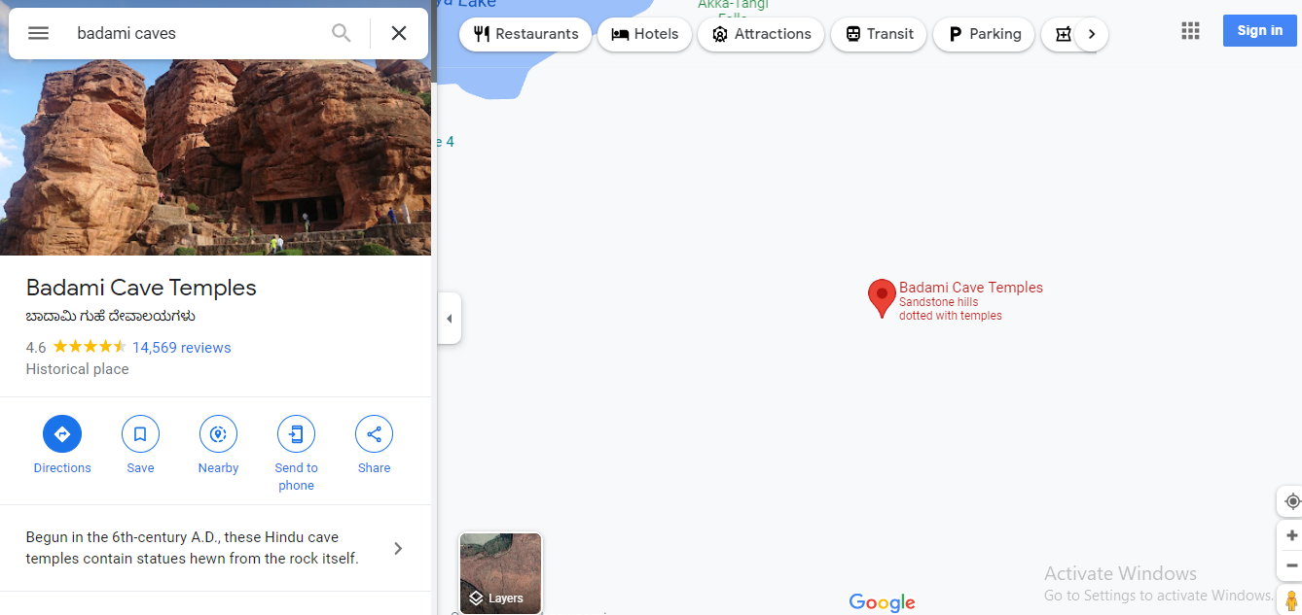**Fig 3.3: Location Of Badami Caves**

**CHAPTER 4**

**KUDALASANGAMA**

**4.1 AIM**

Survey Of Kudalasangama and its history

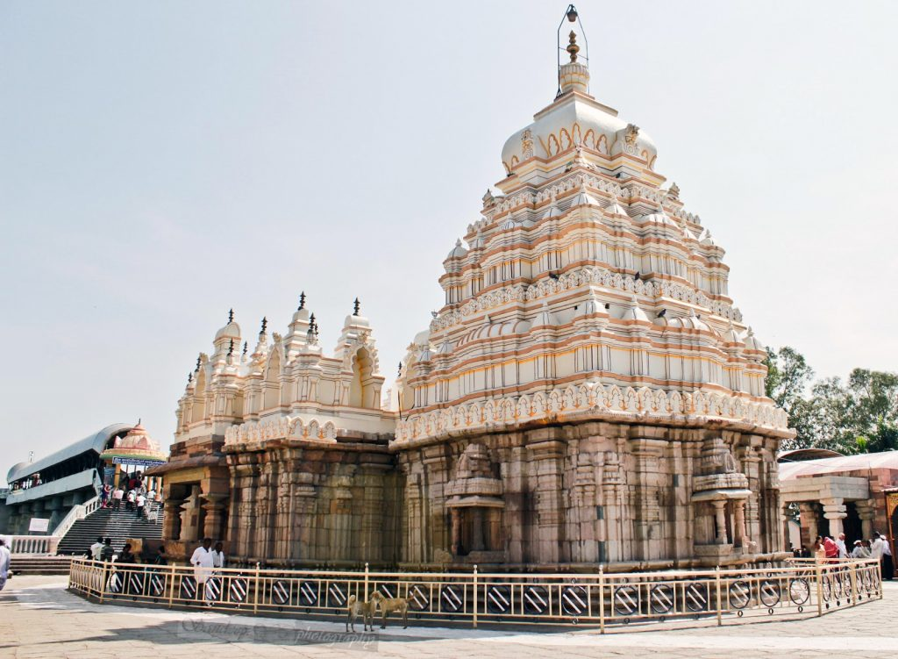

**Fig 4.1: Kudalasangama Temple**

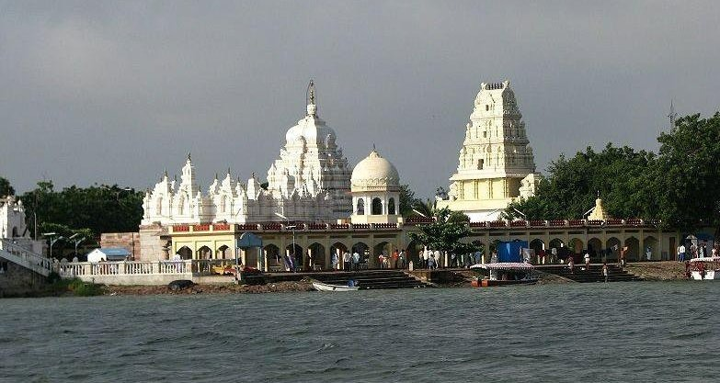

**Fig 4.2: Temple River View**

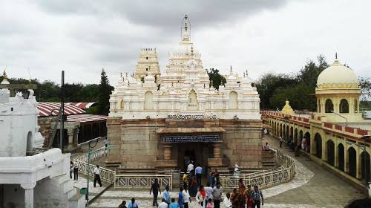

**Fig 4.3: Temple Entrance**

**4.2 HISTORY**

At a distance of 35 km from Aihole, Kudalasangama is a pilgrimage site in the Bagalkot district of Karnataka. At the confluence of Krishna and Malaprabha Rivers, it is one of the popular places to visit in Aihole.   
  
Kudalasangama is famous for 850 years old Sangameswara temple, known as Kudala Sangameswara dedicated to Lord Shiva. Built-in 12th century, the temple is situated on the banks of the Krishna River and it was renovated several times. The temple is constructed in Dravidian style with a large temple tower at the entrance, followed by the main temple with a porch, navaranga and sanctum. The door frame of the garbhagriha is richly carved with floral designs and animal figures.

In front of the temple, amid the river, is a small stone mandapa with a Shivalinga in it, and lofty cement concrete dry well has been built around it to protect it from submersion. The sikhara of the temple is a typical South Indian-style structure. The temple has inscriptions dating back to 1160 AD and 1213 AD.  
  
This place is also associated with famous saint Vishwaguru Basavanna, a great devotee of Lord Shiva and the founder of the powerful Lingayat faith. His samadhi is at Kudalasangama.

Other places of interest in Kudalasangama include Campus of the Basava Dharma Peetha, a Sabha Bhavana with 6000 seating capacity, Basava Gopura - a 200 feet tall symmetrical tower, and a museum. The famous Almatti Dam is located at a distance of 15 km from Kudalasangama.

**4.3 LOCATION**

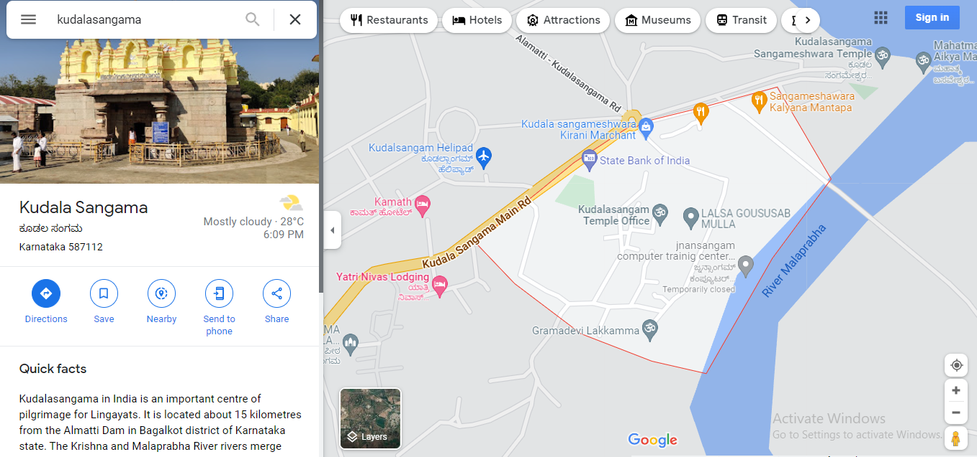

**Fig 4.4: Location Of Kudalasangama**

**4.4 REFERENCE**

[Kudalasangama, Aihole - Timings, History, Pooja & Aarti schedule, (trawell.in)](https://www.trawell.in/karnataka/aihole/kudalasangama)

**CHAPTER 5**

**ALMATTI DAM**

**5.1 AIM**

Survey Of Almatti Dam and its history

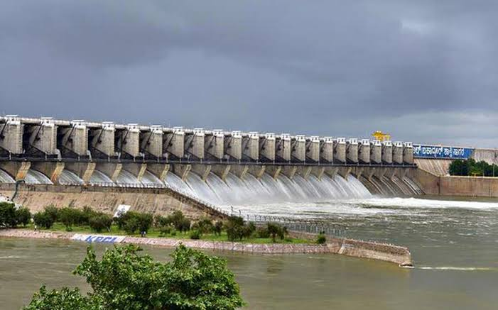

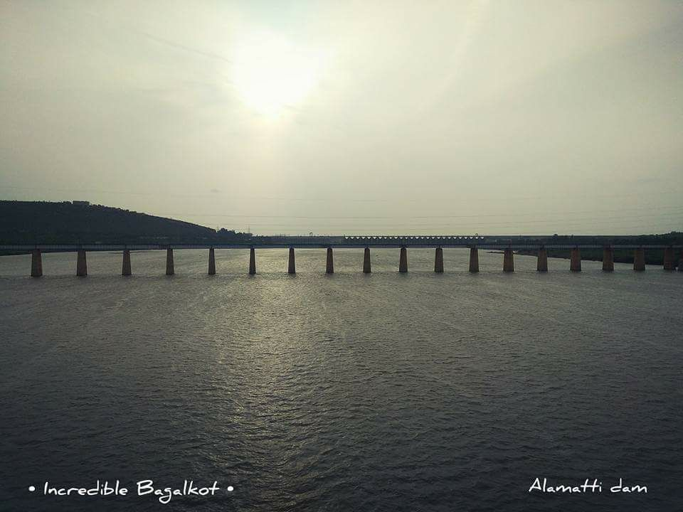

**Fig 5.1: Bridge at Almatti Dam**

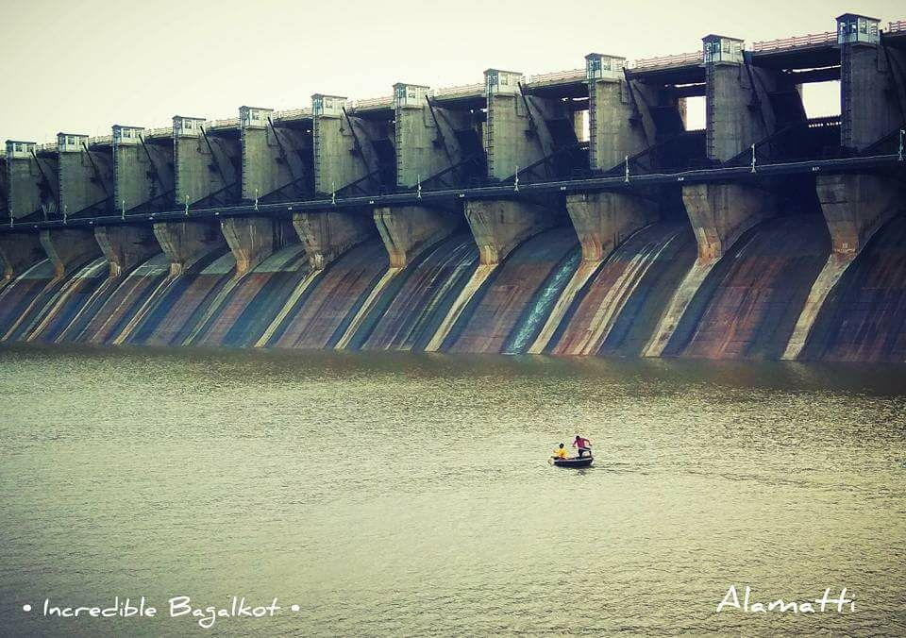

**Fig 5.2: Closed Gate View Of Almatti Dam**

The Almatti Dam is a hydroelectric project on the Krishna River and is located on the edge of Vijayapura and Bagalkot districts. The annual electric output of the dam is 713,000,000 kilowatts (KW). It is the main reservoir of the Upper Krishna Irrigation Project; the 290 megawatt (MW) power project is located on the right side of the Almatti Dam.

The facility uses vertical Kaplan turbines: five 55MW generators and one 15MW generator. During the initial stages of the project, estimated costs were projected as Rs.1470 crores, but following the transfer of project’s management to the Karnataka Power Corporation Limited (KPCL), the estimated cost was reduced by over fifty percent to Rs.674 crores. The KPCL eventually completed the project at an even lower cost of Rs.520 crores. The entire dam was finished in less than forty months, with construction ending in July 2005. The dam holds a gross water storage capacity of 123.08 TMC at 519 meters MSL.

Though the water is diverted for irrigation projects, it also plays host to many leisure activities like boating, musical fountain rock garden etc.

**5.2 LOCATION**

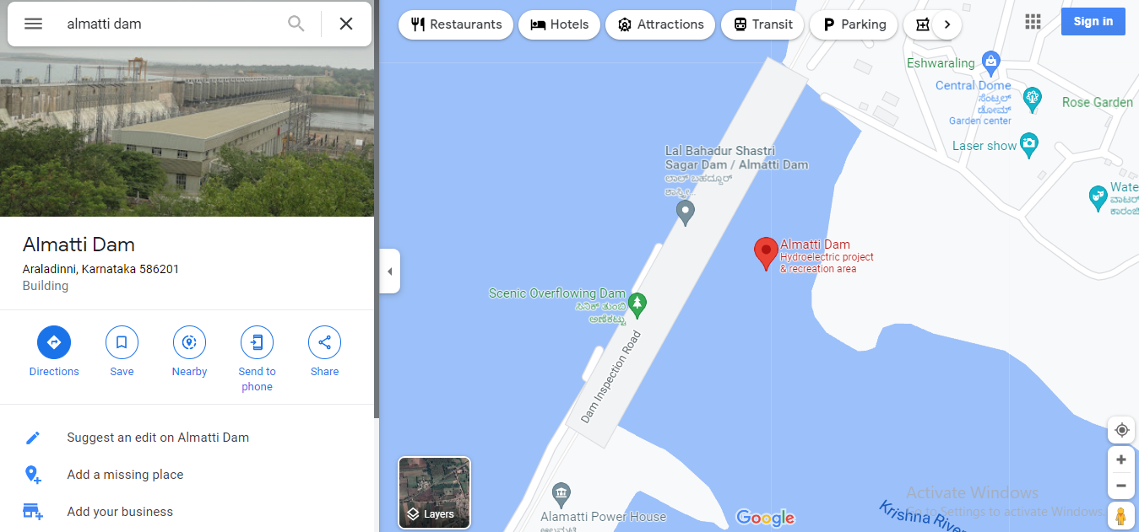

**Fig 5.3: Location Of Almatti Dam**

**5.3 References**

[Bagalkote - Best Palces to Visit in Bagalkote District | Karnataka Tourism](https://www.karnatakatourism.org/tour-item/bagalkote/)

[Almatti Dam | Vijayapura District, Government Of Karnataka | India](https://vijayapura.nic.in/en/tourist-place/almatti-dam/)

**CHAPTER 6**

**MAHAKUTA GROUP OF TEMPLES**

**6.1 AIM**

Survey Of Mahakuta Group Of Temples and their history

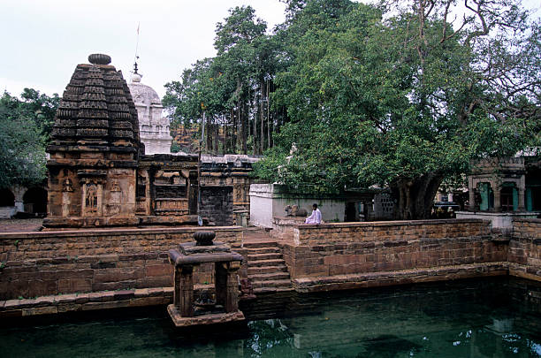

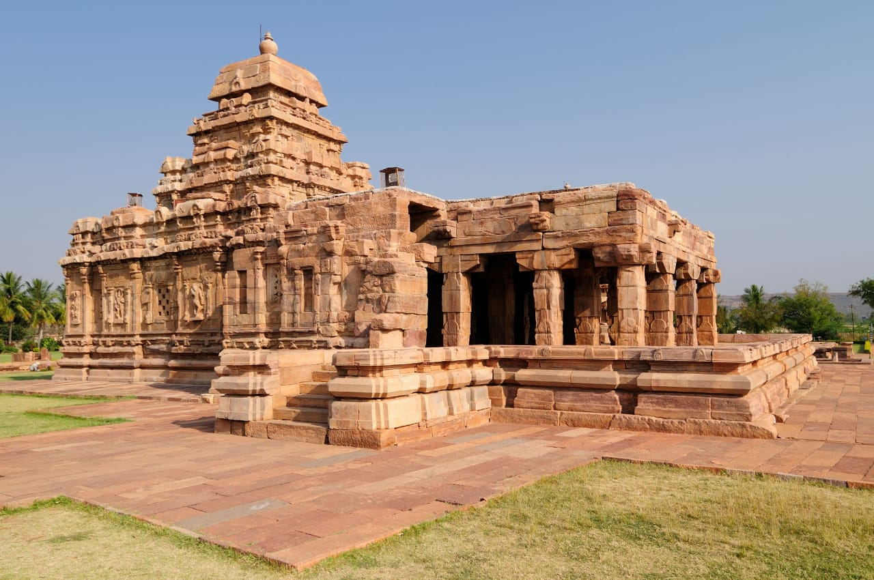

**Fig 6.1: Mahakuta Temple**

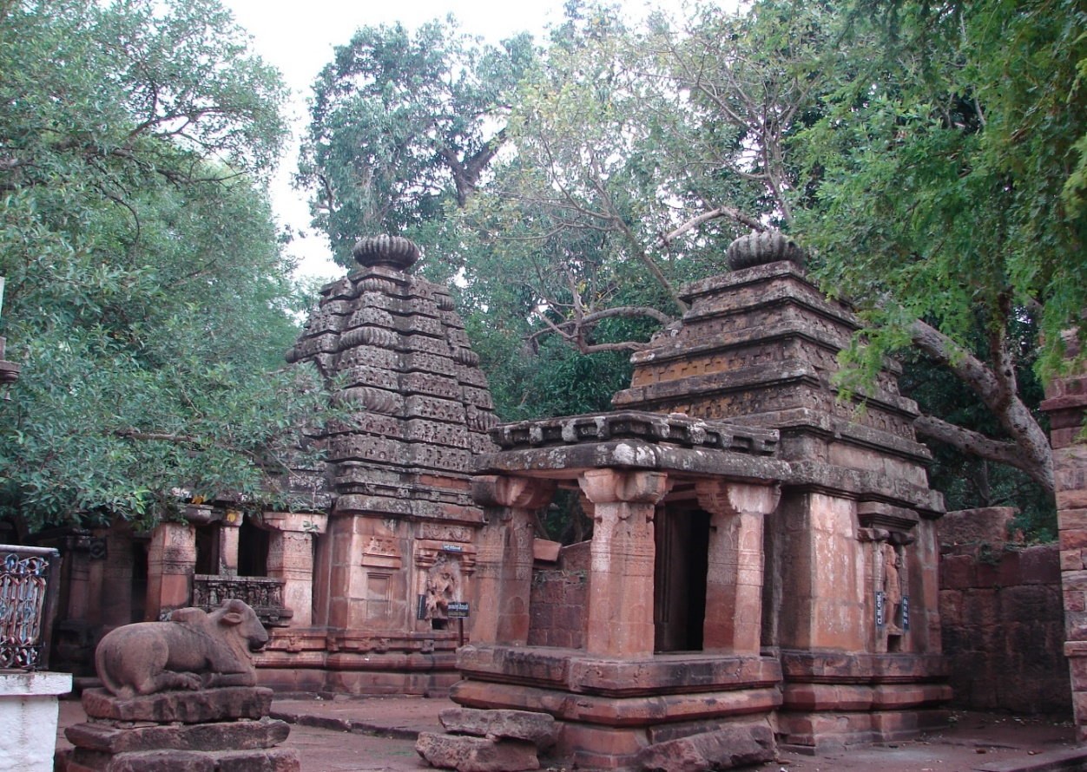

**Fig 6.2: Vishnu Temple**

Situated in the small town in Bagalkot district of Karnataka, Mahakuta Group of temples was built in 6th– 8th Century AD. Mahakuta means “Great Group” and this name is given to the place because of a large number of Lord Shiva temples in the same complex. It is a religious place which has been dedicated totally to Lord Shiva.

**6.2 HISTORICAL IMPORTANCE**

Mahakuta is a significant site for historians especially because of the two key inscriptions discovered in the temple. The inscriptions Pillar and Porch depict the history of Chalukya Dynasty. Brief details about the inscription have been stated below:

**Pillar Inscriptions:**

It is also known as Dharmavijayastambha. This inscription records details about Chalukaya achievements and their military expeditions.

**Porch Inscription:**

This inscription, also known as Vinapoti inscription, is recorded on the porch of the temple and tells the tale about a grant of a silver umbrella and rubies (Called Vinapoti) made to the lord, by Vijayaditya, his concubine.

**6.3 ARCHITECTURE**

Mahakuta Group of temples is a pure reflection of Aihole architectural style buildings. The temples boast a lot about Dravidian and Nagara hybrid style followed by Chalukya. The temples have curvilinear towers over the sanctum. Amongst different temples dedicated to Lord Shiva, the Mahakuteshwara temple is the most prominent one out of them all.

Built in Dravidian style, the temple has a Shiva Linga on top of a curvilinear tower. There are other small temples as well around this main temple, like the temple of Nandi in the front. The walls are decorated with amazing unique carvings of Lord Shiva which attracts visitors to its beauty.

Apart from this, the temple also has a natural water spring fed tank known as Vishnu Pushkarini. Owing to its natural beauty and beautiful carving, this temple is also termed as being similar to Mallikarjuna temple which is located on the other side of Vishnu Pushkarini.

**6.4 LOCATION**

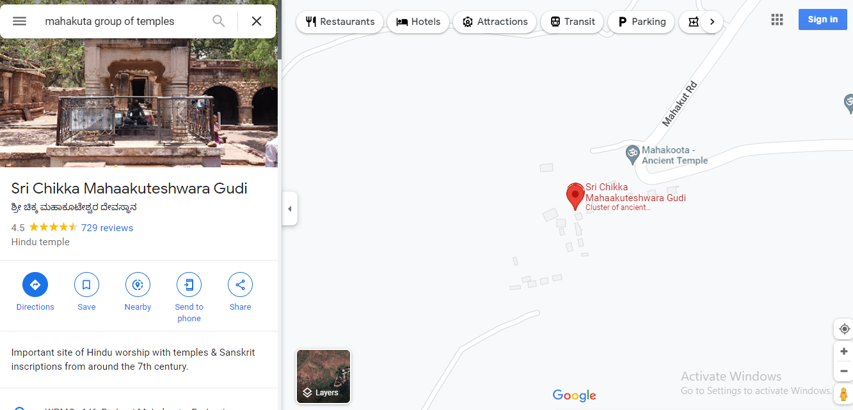

**Fig 6.3: Location Of Mahakuta Group Of Temples**

**CHAPTER 7**

**ROCK GARDEN**

**7.1 AIM**

Survey Of Rock Garden

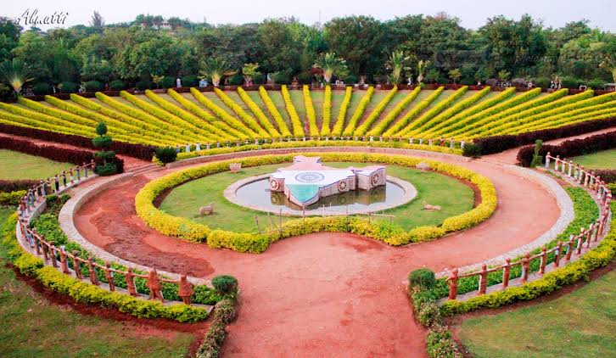

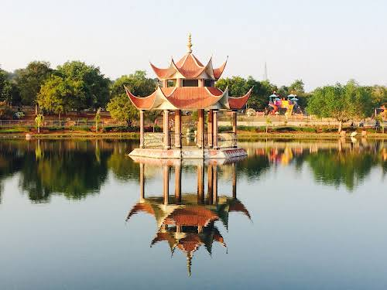

**Fig 7.1: Silver Lake - Almatti Garden**

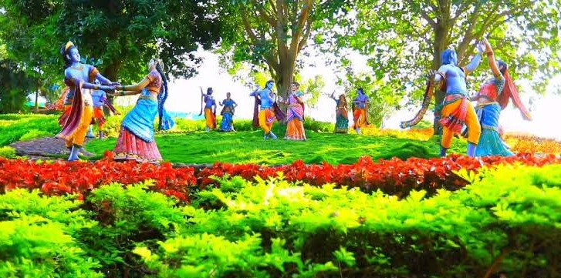

**Fig 7.2: Gopal Krishna Garden Almatti**

Rock Garden is one of the top and best destinations for family and friends in the field of park, Water Parks and resort category in Bagalkot. It is also known as park, Water Parks, resort, Amusement Parks, Water Parks, Picnic Spots, Adventure Parks and much more. Here you can find location, address, phone number, contact number, contact details, reviews and ratings, images of Rock Garden, Bagalkot.

Rock Garden placed in Almatti, Karnataka 586201, and Rock Garden took a good position in the Park category in Bagalkot. If you live in Bagalkot or some where near to Bagalkot than this will be a good and easy destination for you. Rock Garden is a good park in the amusement_park in Bagalkot because a lot of people are visiting this park, people love this park, this park is always clean, people do not have any problem in coming here and spending time. This is because there are many more entertainment facilities available here. This park also has a safe place for children, people do not face any problem and people can easily entertain here. In Bagalkot, this park is well known by all and this park enjoys a high status in the category of parks. It is known to offer superior services in the following categories: park , Amusement Parks , Water Parks, Resorts, Picnic Spots.

**GOPAL KRISHNA PARK**

The Krishna park is created just opposite to ARBC jack well. The location of this park has its own scenic beauty. Hence, the area was chosen for development of garden. Because of Krishna river, Lord Krishna is taken as a theme. The pranks, mischief and cleverness are depicted artistically which is attracting the thousands of tourist.

Here the area covered is 3 acres, In this garden almost complete area is covered with lawn, hedges, flowerbeds, ground cover, shrubs and trees. Along with this gardening works, Sculptures of Yashoda Krishna, Gopal Krishna, Rasleela of Krishna, Shanka and Chakra, Krishna Gopika’ s scenes are created and decorated artistically. Even the compound wall gate is decorated artistically related to Krishna and nature.

This marvelous and beautiful garden is attracting thousands of visitors. To make this garden more attractive surrounding areas like In front of ARBC headwork, around canteen area and along the aqueduct, fruit orchards and survey no.22 are developed with lawn, hedges, ground cover, flower beds and ornamental shrubs and fruit yielding hybrid varieties of mango, chikoo, guava, mandarin and jackfruit, custard apple, wood apple, rose apple etc are planted.

To maintain the glory of this garden regular care is taken to maintain those Sculptures with painting and minor repairs.

**7.2 LOCATION**

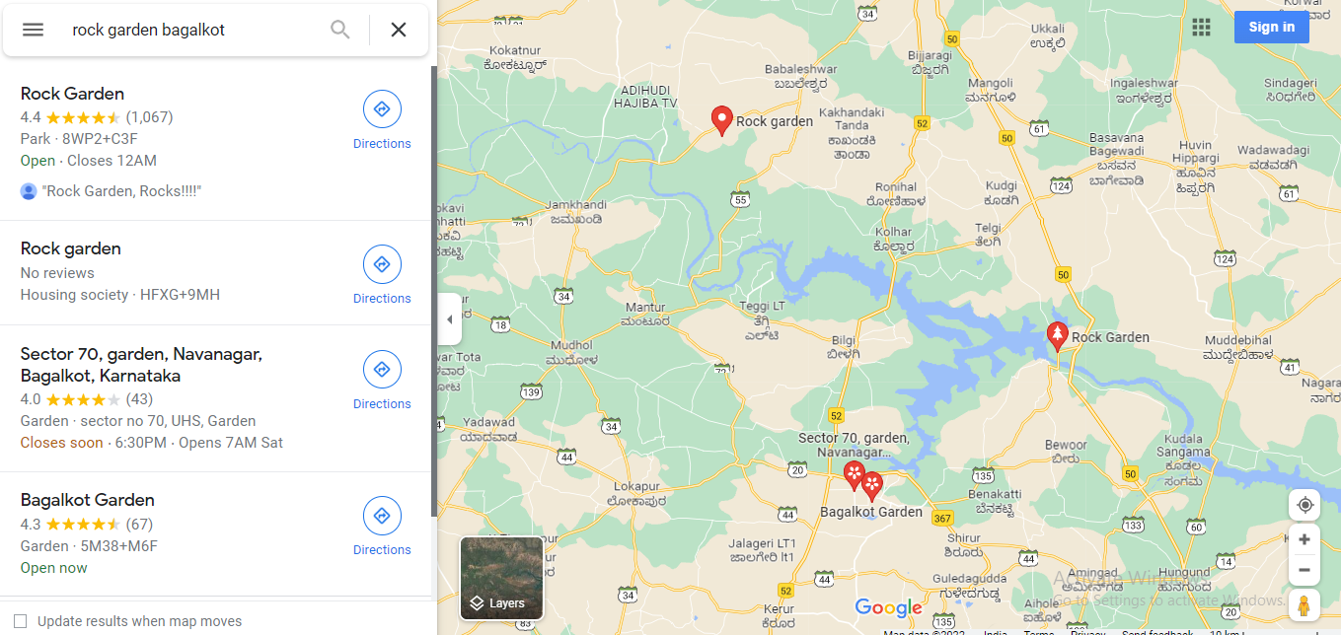

**Fig 7.3 Location Of Rock Garden**

**7.3 REFERENCE**

[**https://kbjnl.karnataka.gov.in/inf02/Garden+at+Almatti+(Tourism)/em**](https://kbjnl.karnataka.gov.in/inf02/Garden+at+Almatti+(Tourism)/em)